Project: Skywriter School
Difficulty: Level 1

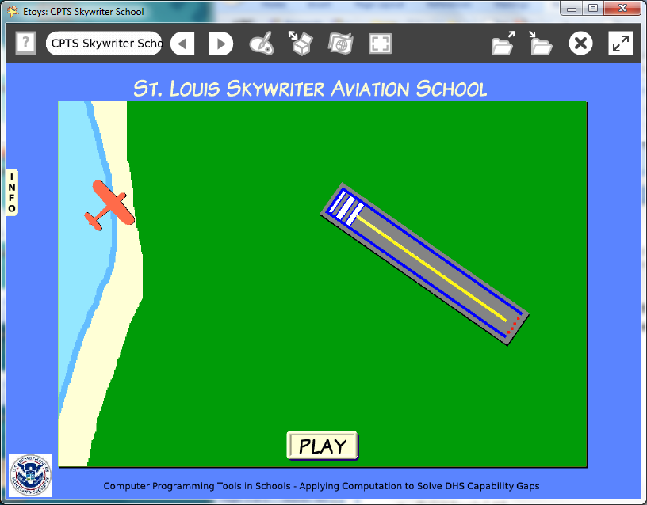

Time: Three 45 minute labs

Challenge:
Make a project that guides an aircraft to safe landing. Script a safe landing message. Include information about careers in aviation.

Programming:
This project has only a few scripts. Students will need time to experiment with the new tiles. Drawings for the background, runway, and the airplane take time too.

Things you’ll need to know:
Quick Guides
- Paint Tools/ All
- Halo Handles/All
- Supplies: Text, Add a New Flap
- Script Tiles: Forward by, X and Y Tiles, Pen Use, Playfield, Heading, Hide and Show, Exact Location, Tests Category
- Menus: Normal Ticking, Scriptor Icons Set, Button Fires a Script
- There are no Quick Guides for the tiles in Miscellaneous: draw-new-path, follow-existing-path. The phrase starts: sketch do menu item send to back and is the first in a large menu of options.

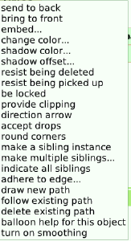

- There are no Quick Guides for Scripting tiles that are used in conditional statements or scripts set to Normal, to start, pause and stop scripts.

Things to think about:
- This Etoys project was inspired by the FlightCtrl HD App on the iPad. If there is access to an iPad, show the App to students and after they see the way it works show the Credits information.
- Discuss the importance of teams in programming
- Ask students to count the number of people who worked on the iPad app; the Credits show more than twenty-one names.
- Ask students to note the type and number of Credit’s categories: Art, Production, Programming
- Ask students to estimate how long it would take one person to make a similarly finished product and discuss how many skills one person would need: art, programmer, musician, marketing, and more
- Give students time to read www.faa.gov to learn about careers and training for airline pilots, controllers, and mechanics.
- Give students time to read about the career paths: www.dhs.gov

Extensions:
- Increase the number of airplanes and runways
- Include a penalty for crash landings
- Use a variable for time to limit the length of the game
- Use a variable to keep count of the number of safe landings
- Increase the level of difficulty of the game by increasing the airplanes forward speed.
- Add music. Research open source music files. Give credit to musicians and composers.

NETS for Students:
http://www.iste.org/standards/nets-for-students/nets-student-standards-2007.aspx
1. Creativity and Innovation: a, b, c
2. Communication and Collaboration: b
3. Research and Information Fluency: a, b
4. Critical Thinking, Problem Solving, and Decision Making: a
5. Digital Citizenship: a, b
6. Technology Operations and Concepts: a, b, c, d

CSTA:
CSTA Level II: Objectives and Outline
http://csta.acm.org/Curriculum/sub/CurrFiles/L2-Objectives-and-Outlines.pdf
Level II objectives for middle school students are furthered through studying a programming language well enough that the student is proficient with it. Whether the language is Etoys, StarLogo TNG, or Scratch, it is the ability to use the language to express ideas that is valuable. A student skillful enough to use any programming language to express ideas, solve problems, model behaviors, simulate data, or to educate or entertain is an entitled person in today’s society.
Topics of particular note are:
Topic 2: Problem Solving
Topic 6: Connections between Mathematics and Computer Science
Topic 11: Programming Languages
Topic 13: Multimedia

Common Core Standards Mathematics:
http://www.corestandards.org/the-standards/mathematics
6. NS.6, 6. EE.2

Teacher Notes:
Materials: Show the iPad app if at all possible so students can place the work they do in this project in a larger context of commercial products.
www.fas.gov
www.dhs.gov

Comments: Objects - Scripts – Decisions
The scripts use some constructed scripts which take time to understand. For example; airplane’s heading is runway’s heading.
The reset script uses random number variables so to provide a variety of challenges for the locations and heading of the airplane and the runway.

Example Scripts:
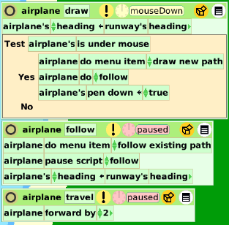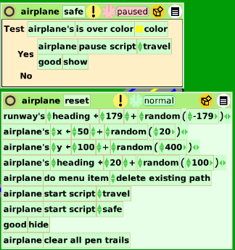

Student Notes:
None provided.

